Registration No: 2025/CS/079
Index No: 25000799
Exercise 01
01.
a) Invalid | b) Valid
c) Valid | d) Invalid
e) Invalid | f) Valid
g) Valid | h) Invalid
i) Invalid | j) Invalid

02.
#include <stdio.h>

int main() {
printf(“Size of int : %zu\n”, sizeof(int));
printf(“Size of char : %zu\n”, sizeof(char));
printf(“Size of long : %zu\n”, sizeof(long));
printf(“Size of short : %zu\n”, sizeof(short));
printf(“Size of float : %zu\n”, sizeof(float));
printf(“Size of double : %zu\n”, sizeof(double));
printf(“Size of long double : %zu\n”, sizeof(long double));
}

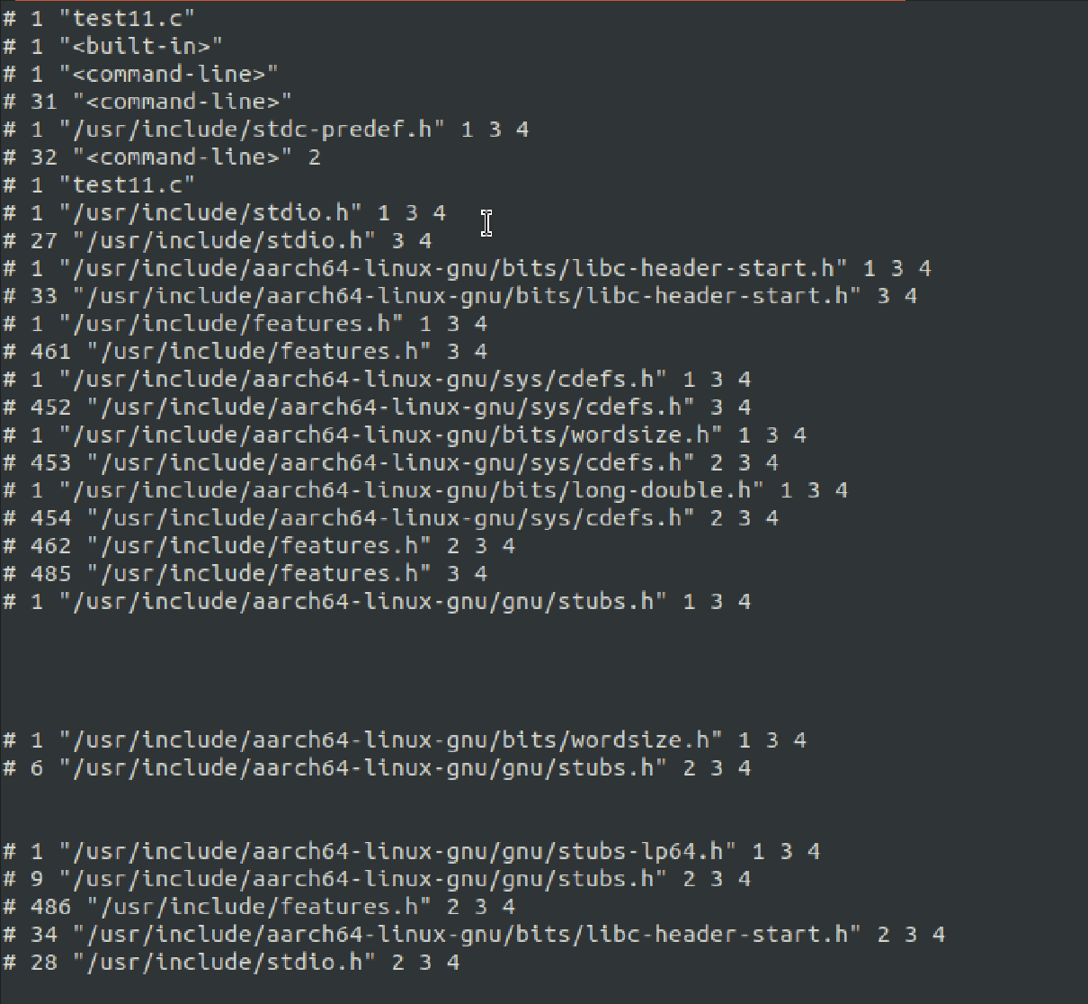
03.
( a )

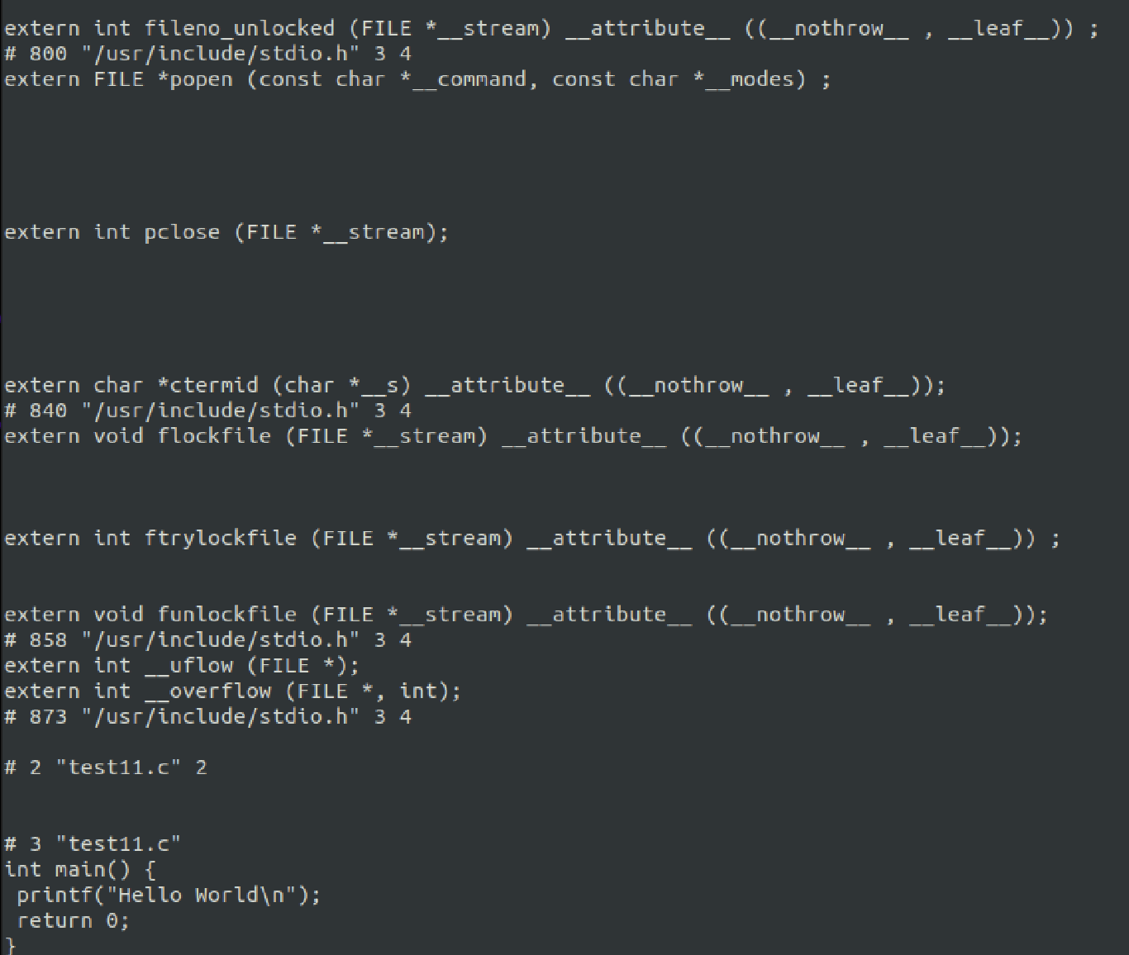

( b )
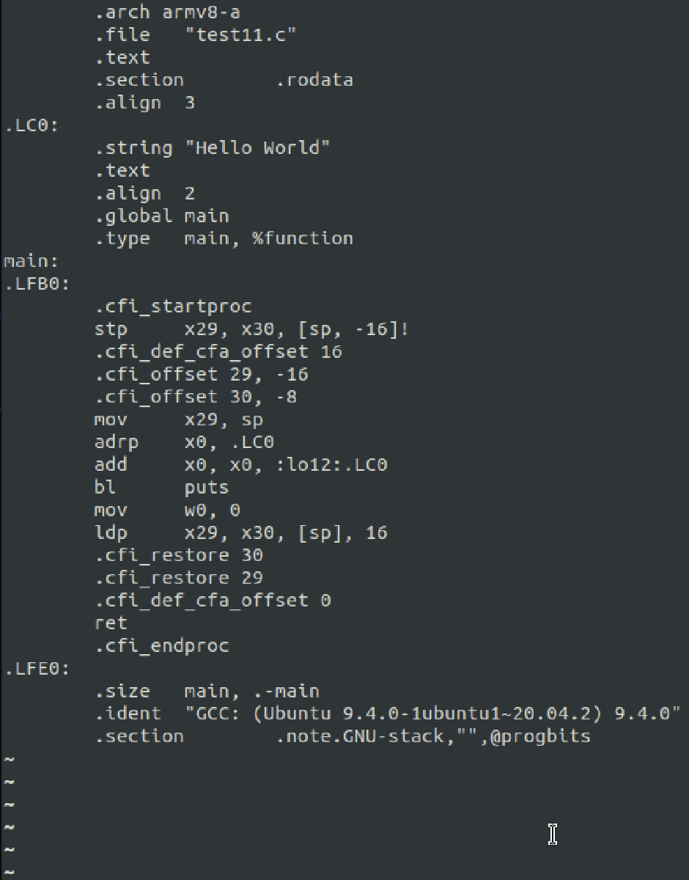

( c )
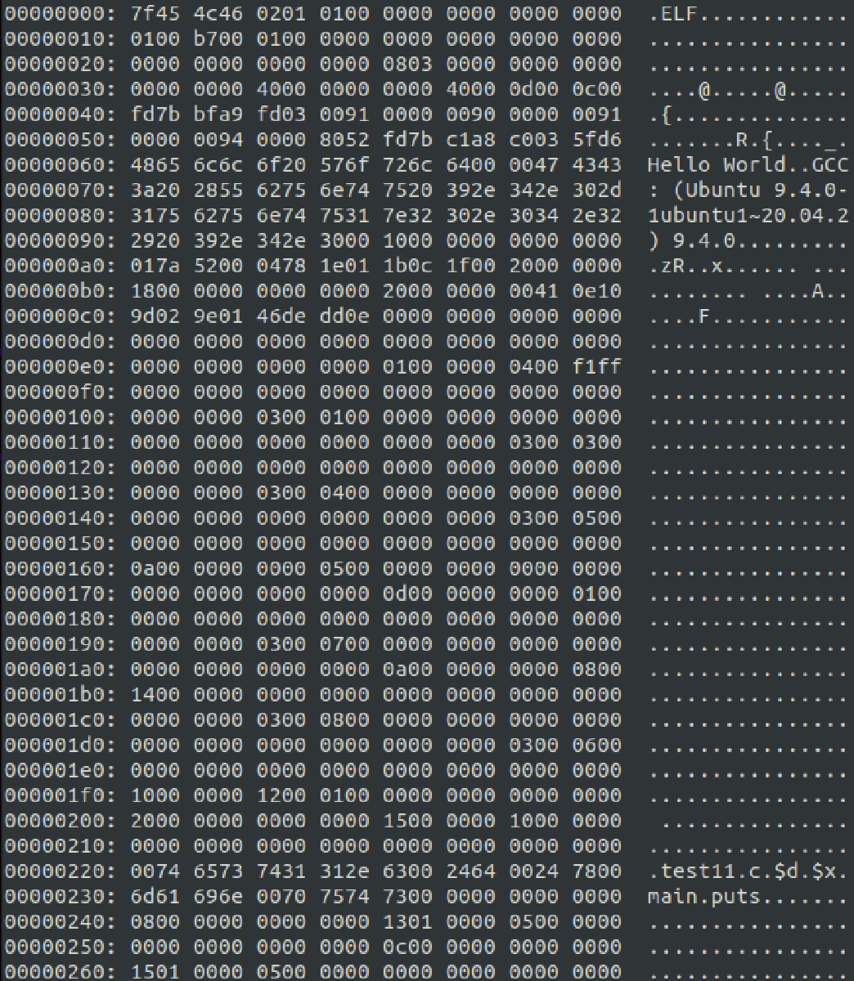

( d )
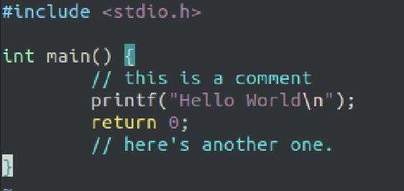
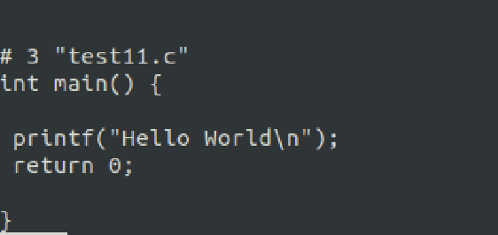
( e )
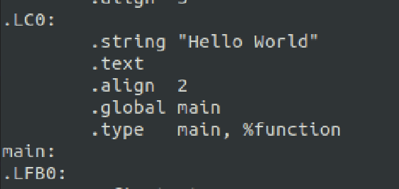

04.
#include <stdio.h>
#include <limits.h>
#include <float.h>

int main() {
printf(“Range of Int : %d to %d\n”, INT_MIN, INT_MAX);
printf(“Range of char : %d to %d\n”, CHAR_MIN, CHAR_MAX);
printf(“Range of long : %ld to %ld\n”, LONG_MIN, LONG_MAX);
printf(“Range of short : %d to %d\n”, SHRT_MIN, SHRT_MAX);
printf(“Range of float : %f to %f\n”, FLT_MIN, FLT_MAX);
printf(“Range of double : %f to %f\n”, DBL_MIN, DBL_MAX);
printf(“Range of long double : %Lf to %Lf\n”, LDBL_MIN, LDBL_MAX);
}

05.
( a )
#include <stdio.h>

int main() {
double x = 125.456734516547332453425;
printf(“i) %.6f\n”, x);
printf(“ii) %.3f\n”, x);
printf(“iii) %+.0e\n”, x);
printf(“iv) %.6E\n”, x);
printf(“v) %A\n”, x);
}

( b )
#include <stdio.h>

int main() {
int y = 76;
printf(“i) %d\n”, y);
printf(“ii) %x\n”, y);
printf(“iii) %X\n”, y);
printf(“iv) %o\n”, y);
printf(“v) %#x\n”, y);
printf(“vi) %#X\n”, y);
printf(“vii) %#o\n”, y);
printf(“viii) %010d\n”, y);
printf(“ix) %10d\n”, y);
}

( c )
#include <stdio.h>

int main() {
int day, month, year, hour, minute;
day = 30;
month = 4;
year = 2024;
hour = 12;
minute = 57;

printf(“i) %d-%02d-%d %d:%d\n”, year, month, day, hour, minute);
printf(“ii) %d/%02d/%d %d:%d Hrs\n”, day, month, year, hour, minute);
printf(“iii) %d.%d.%d %d Hours %d Minutes\n”, month, day, year, hour, minute);
printf(“iv) %x%d%d-%03d%03d \n”, year, month, day, hour, minute);
}

( d )
#include <stdio.h>

int main() {
char c = ‘A’;
printf(“i) %c\n”, c);
printf(“ii) %d\n”, c);
}

